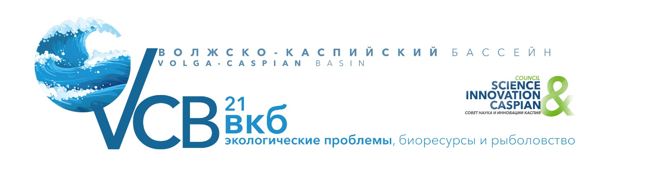

Conference with international participation
"Environmental problems, the biological resources and fishing in the Volga-Caspian basin»
Organizers: Council "Science and Innovations of the Caspian Sea", IPEE RAS, Russian Committee for UNESCO program "Man and the Biosphere", VNIRO.
Venue: Moscow, IPEE RAS.
Dates: April 28-29, 2021, 10: 00-18: 00.
Topics for discussion:

- National state environmental policy, environmental legislation and legislative support for fisheries in the Volga-Caspian Basin
- The current state of environmental monitoring of the natural environment, bioresources, ensuring environmental safety, forecasting, identifying and overcoming natural and man-made emergencies in the region
- International environmental cooperation and international expeditions to monitor the ecosystem and bioresources in the Volga-Caspian basin
- The importance of biosphere reserves in preserving the ecosystem of the Volga-Caspian basin
- Biotechnologies, ways of preserving, rational use and improving the efficiency of reproduction of water bioresources in the region
- Current state and prospects of aquaculture development in the region
- Fisheries and prospects for the development of the fishing fleet in the Volga-Caspian basin
- The state and development of amateur and sport fishing in the Volga-Caspian fishery Basin and its impact on the conservation of aquatic biological resources of the Volga and the Caspian Sea
- Measures, technologies and equipment to effectively reduce IUU fishing in the region
- Experience in the use of GIS technologies and satellite monitoring in research on biological diversity and fisheries development in the Volga-Caspian Basin
- Introduction the industrial, energy, agricultural, transport and other sectors of the Volga-Caspian basin resource-saving, environmentally friendly technologies and equipment, management and technical solutions, advanced development and other innovative product in order to minimize and prevent a negative impact on the environment
- Environmental management
- Insurance of economic activity in the region
Сo-moderators:
- Vyacheslav Rozhnov, Academician of RAS, Director of A.N. Severtsov Institute of Ecology and Evolution of the Russian Academy of Sciences, the President of the Theriological society at the Russian Academy of Sciences, head of the permanent wounds of the expedition to study animals of the red book of the Russian Federation and other important animals of the fauna of Russia, head of the Kazakh-Russian research Program of the Caspian seal in the Northern Caspian (2019-2023 years), Research Supervisor of the Council of "Science and Innovations of the Caspian Sea»
- Victor Danilov-Danil'yan, Corresponding Member of RAS, doctor of Economics, scientific Director of the Institute of water problems of RAS
- Kirill Kolonchin, Director of the All-Russian Research Institute of Fisheries and Oceanography
- Yuri Dgebuadze, academician of RAS, head of Section of the General biology Department of biological Sciences, head of the laboratory of ecology of aquatic communities and infestations Institute of ecology and evolution Russian Academy of Sciences, Chairman of the Russian Committee of the UNESCO Program "Man and biosphere" (MAB), co-Chairman of the Presidium of the Council "Science and innovations of the Caspian sea"
- Amirkhan Amirkhanov, Deputy Head of the Federal service for supervision in the sphere of nature management (Rosprirodnadzor)
- Tatyana Balagula, Head of the Department of Internal Veterinary Supervision of the Rosselkhoznadzor
Invited speakers:
- Denis Khramov, First Deputy Minister of Natural Resources and Environment of the Russian Federation
- Sergey Mitin, First Deputy Chairman of the Committee on Agrarian and Food Policy and Environmental Management of the Federation Council of the Russian Federation
- Representatives of the Ministries of Ecology of the Caspian countries
- Behrouz Abtahi, Director of the Iranian National Institute of Oceanography and Atmospheric Sciences
- Yuri Dgebuadze, Academician of RAS, head of Section of the General biology Department of biological Sciences, Head of the laboratory of ecology of aquatic communities and infestations Institute of ecology and evolution Russian Academy of Sciences, Chairman of the Russian Committee of the UNESCO Program "Man and biosphere" (MAB)
- Representative of the Federal Agency for Fisheries
- Albert Kasparov, Acting Director of HGBWW "Of"
- Representatives of the Ministry of natural resources and ecology of the Caspian
- Mihail Glubokovsky, Scientific Director of the All-Russian Research Institute of Fisheries and Oceanography (VNIRO)
- Aleksandr Chibilev, Academician, Vice-President of the Russian geographical society, the Main researcher of the Department of landscape ecology, Institute of steppe, Ural branch of the Russian Academy of Sciences is a separate structural unit of the Orenburg INSTITUTE, Federal research center, Ural branch of the Russian Academy of Sciences
- Anna Belousova, Candidate of Biological Sciences, Head of the Red Book Laboratory of the Federal State Budgetary Institution "VNII Ekologiya»
- Elena Ostrovskaya, Director of the Caspian Marine Research Center»
- Yuri Gerasimov, Deputy Director for Scientific Work of the I. D. Papanin Institute of Biology of Inland Waters of the Russian Academy of Sciences»
- Vladimir Ushivtsev, Director of the Caspian Branch of the P. P. Shirshov Institute of Oceanology of the Russian Academy of Sciences
- Magomed Jafarov, Head of the North Caucasus Territorial Administration of the Federal Agency for Fisheries
- Alexander Morozov, Head of the Volga-Caspian Territorial Administration of the Federal Agency for Fisheries
- Konstantin Markelov, Rector of Astrakhan State University
- Alimurad Gadzhiev, Director of the Institute of Ecology and Sustainable Development (DSU), Candidate of Biological Sciences, Corresponding Member of the Ecological Academy of Sciences of Russia
- Tamara Shiganova, doctor of biological Sciences FSBIS "Institute of Oceanology P. p. Shirshov wounds"
- Lev Desinov, Head of laboratory of remote sensing, Institute of geography RAS, corresponding Member of the Academy of cosmonautics.
- NC OMZ JSC RKS
Invited speakers and participants of online discussions:
- Representatives of other executive authorities of the Russian Federation
- Heads and representatives of state authorities of the subjects of the Russian Federation of the Volga-Caspian basin
- Heads and representatives of state authorities of the Caspian regions of the Caspian countries
- Heads of committees of the UNESCO Program "Man and the Biosphere" (IAB) of the Caspian countries
- Heads and experts of scientific institutions, companies and organizations of Azerbaijan, Iran, Kazakhstan, Turkmenistan
- Heads of the State Natural Biosphere Reserves of the Volga-Caspian Basin
- Heads and experts of public organizations, Unions and Associations
- Heads of economic entities of the region, representatives of business circles of Russia and the Caspian countries

Within the framework of the Conference, it is proposed to hold an online briefing with the media, business face-to-face and online negotiations on the issues discussed at the conference.

CO-CHAIRmanS OF THE ORGANIZING COMMITTEE:
- Vyacheslav Rozhnov, Academician of RAS, Director of A.N. Severtsov Institute of Ecology and Evolution of the Russian Academy of Sciences, the President of the Theriological society at the Russian Academy of Sciences, head of the permanent wounds of the expedition to study animals of the red book of the Russian Federation and other important animals of the fauna of Russia, head of the Kazakh-Russian research Program of the Caspian seal in the Northern Caspian (2019-2023 years), Research Supervisor of the Council of "Science and Innovations of the Caspian Sea»
- Kirill Kolonchin, Director of the Russian research Institute of fisheries and Oceanography
CO-CHAIRMANS OF THE PROGRAM COMMITTEE:
- Yuri Dgebuadze, Academician of RAS, head of Section of the General biology Department of biological Sciences, Head of the laboratory of ecology of aquatic communities and infestations Institute of ecology and evolution Russian Academy of Sciences, Chairman of the Russian Committee of the UNESCO Program "Man and biosphere" (MAB)
- Mihail Glubokovsky, Scientific Director of the Russian research Institute of fisheries and Oceanography (VNIRO)

